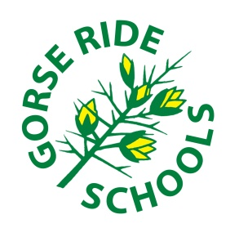
GORSE RIDE SCHOOLS
GROW | RESPECT | SUCCEED

HOME - SCHOOL AGREEMENT
Gorse Ride Schools will:
- Provide a varied and balanced curriculum, supported by home learning that meets the needs of the individual and promotes a life-long enjoyment of learning
- Encourage and support all children to do their best at all times
- Aim for consistent high standards of work and behaviour through building good relationships and developing a sense of collective responsibility
- Ensure the family and Informed about general school matters and of each child’s progress
- Let the family know about any concerns that might affect their child’s work or behaviour
- Communicate promptly in the event of an emergency or other cause for concern
- Instil moral values like honesty, loyalty, respect, self-reliance, self-discipline, patience, kindness, gratitude, forgiveness, personal responsibility and courtesy.

My Family will:
- Make sure that I come to school regularly, arrive in class on time and ensure that I am properly equipped, including smart school uniform and appropriate footwear
- Make sure that I come to school having had breakfast and a good night’s sleep
- Support the school’s policies and behaviour statement
- Support me in home learning and other extended opportunities
- Attend all parents’ evenings to discuss my progress
- Hear me read every day
- Ensure I take good care of the school property I take home
- Show an active interest my life at school and attend events and information evenings
- Ensure that I bring a water bottle to school every day
- Support the school’s values and reinforce good values at home

I will try to:
- Be organised, making sure that I have everything I need for each lesson
- Read to an adult at home every day
- Remember to be polite and respectful to other pupils, my friends and teachers at all times
- Remember to always say please and thank you
- Do my best learning at all times
- Be proud to wear my school uniform
- Behave sensibly and calmly

GORSE RIDE SCHOOLS
GROW | RESPECT | SUCCEED

GORSE RIDE SCHOOLS
HOME - SCHOOL AGREEMENT
In signing this document,
all parties are entering into a partnership and committing to work together for the benefit of each child

SIGNATURES
Child’s Name :
Child’s Signature :
Parent / Guardian’s Name :
Parent / Guardian’s Signature :
Executive Head Teacher’s Name : | Miss Eileen Rogers
Executive Head Teacher Signature :

Please sign and return to school

